**PRACTICAL-8.2**

**AIM:**

**Create an application in which user pass the data with intent object to another activity.**

**PROGRAM CODE:**

* **AndroidManifest.xml:**

*<?*xml version="1.0" encoding="utf-8"*?>*<manifest xmlns:android="http://schemas.android.com/apk/res/android"  
 package="com.parthnpatel.intentactivity">  
  
 <application  
 android:allowBackup="true"  
 android:icon="@mipmap/ic_launcher"  
 android:label="@string/app_name"  
 android:roundIcon="@mipmap/ic_launcher_round"  
 android:supportsRtl="true"  
 android:theme="@style/Theme.IntentActivity">  
 <activity android:name=".SecondActivity"></activity>  
 <activity  
 android:name=".MainActivity"  
 android:exported="true">  
 <intent-filter>  
 <action android:name="android.intent.action.MAIN" />  
  
 <category android:name="android.intent.category.LAUNCHER" />  
 </intent-filter>  
 </activity>  
 </application>  
  
</manifest>

* **Activity_main.xml:**

<?xml version="1.0" encoding="utf-8"?>  
<androidx.constraintlayout.widget.ConstraintLayout xmlns:android="http://schemas.android.com/apk/res/android"  
 xmlns:app="http://schemas.android.com/apk/res-auto"  
 xmlns:tools="http://schemas.android.com/tools"  
 android:layout_width="match_parent"  
 android:layout_height="match_parent"  
 tools:context=".MainActivity">  
  
 <TextView  
 android:id="@+id/display"  
 android:layout_width="wrap_content"  
 android:layout_height="wrap_content"  
 android:text="@string/parth_patel_19dcs098"  
 android:textSize="20sp"  
 app:layout_constraintBottom_toBottomOf="parent"  
 app:layout_constraintHorizontal_bias="0.473"  
 app:layout_constraintLeft_toLeftOf="parent"  
 app:layout_constraintRight_toRightOf="parent"  
 app:layout_constraintTop_toTopOf="parent"  
 app:layout_constraintVertical_bias="0.113" />  
  
 <EditText  
 android:id="@+id/enteredText"  
 android:layout_width="243dp"  
 android:layout_height="53dp"  
 android:layout_marginTop="72dp"  
 android:ems="10"  
 android:hint="@string/enter_text"  
 android:importantForAutofill="no"  
 android:inputType="textPersonName"  
 app:layout_constraintEnd_toEndOf="parent"  
 app:layout_constraintHorizontal_bias="0.497"  
 app:layout_constraintStart_toStartOf="parent"  
 app:layout_constraintTop_toBottomOf="@+id/display"  
 tools:ignore="SpeakableTextPresentCheck,TextContrastCheck" />  
  
 <Button  
 android:id="@+id/button"  
 android:layout_width="wrap_content"  
 android:layout_height="wrap_content"  
 android:layout_marginTop="148dp"  
 android:backgroundTint="#009688"  
 android:text="@string/submit"  
 android:textColor="#000000"  
 app:layout_constraintBottom_toBottomOf="parent"  
 app:layout_constraintEnd_toEndOf="parent"  
 app:layout_constraintHorizontal_bias="0.498"  
 app:layout_constraintStart_toStartOf="parent"  
 app:layout_constraintTop_toBottomOf="@+id/enteredText"  
 app:layout_constraintVertical_bias="0.0"  
 tools:ignore="TextContrastCheck" />  
  
</androidx.constraintlayout.widget.ConstraintLayout>

* **Activity_second.xml:**

<?xml version="1.0" encoding="utf-8"?>  
<androidx.constraintlayout.widget.ConstraintLayout xmlns:android="http://schemas.android.com/apk/res/android"  
 xmlns:app="http://schemas.android.com/apk/res-auto"  
 xmlns:tools="http://schemas.android.com/tools"  
 android:layout_width="match_parent"  
 android:layout_height="match_parent"  
 android:background="#FFEB3B">  
  
 <TextView  
 android:id="@+id/displayText"  
 android:layout_width="wrap_content"  
 android:layout_height="wrap_content"  
 android:fontFamily="casual"  
 android:textColor="#F44336"  
 android:textSize="24sp"  
 app:layout_constraintBottom_toBottomOf="parent"  
 app:layout_constraintEnd_toEndOf="parent"  
 app:layout_constraintStart_toStartOf="parent"  
 app:layout_constraintTop_toTopOf="parent" />  
</androidx.constraintlayout.widget.ConstraintLayout>

* **Strings.xml:**

<resources>  
 <string name="app_name">IntentActivity</string>  
 <string name="parth_patel_19dcs098">PARTH PATEL-19DCS098</string>  
 <string name="enter_text">Enter Text</string>  
 <string name="submit">SUBMIT</string>  
</resources>

* **MainActivity.java:**

package com.parthnpatel.intentactivity;  
  
import androidx.appcompat.app.AppCompatActivity;  
  
import android.content.Intent;  
import android.os.Bundle;  
import android.view.View;  
import android.widget.Button;  
import android.widget.EditText;  
  
public class MainActivity extends AppCompatActivity {  
  
 private EditText text;  
 private Button button;  
  
 @Override  
 protected void onCreate(Bundle savedInstanceState) {  
 super.onCreate(savedInstanceState);  
 setContentView(R.layout.activity_main);  
  
 text=findViewById(R.id.enteredText);  
 button=findViewById(R.id.button);  
  
 button.setOnClickListener(new View.OnClickListener() {  
 @Override  
 public void onClick(View view) {  
  
 String str=text.getText().toString();  
  
 Intent intent=new Intent(getApplicationContext(),SecondActivity.class);  
  
 intent.putExtra("Display_Message",str);  
  
 startActivity(intent);  
 }  
 });  
  
  
 }  
}

* **SecondActivity.java:**

package com.parthnpatel.intentactivity;  
  
import android.content.Intent;  
import android.os.Bundle;  
import android.widget.TextView;  
import android.widget.Toast;  
  
import androidx.appcompat.app.AppCompatActivity;  
  
public class SecondActivity extends AppCompatActivity {  
  
 private TextView displayText;  
  
 @Override  
 protected void onCreate(Bundle savedInstanceState) {  
 super.onCreate(savedInstanceState);  
 setContentView(R.layout.activity_second);  
  
 Toast.makeText(getApplicationContext(), "NEW ACTIVITY STARTED!!", Toast.LENGTH_SHORT).show();  
 Toast.makeText(getApplicationContext(), "THE MESSAGE IS DISPLAYED!!", Toast.LENGTH_SHORT).show();  
  
 Intent intent=getIntent();  
  
 String displayString=intent.getStringExtra("Display_Message");  
  
 displayText=findViewById(R.id.displayText);  
  
 displayText.setText(displayString);  
 }  
}

**OUTPUT:**

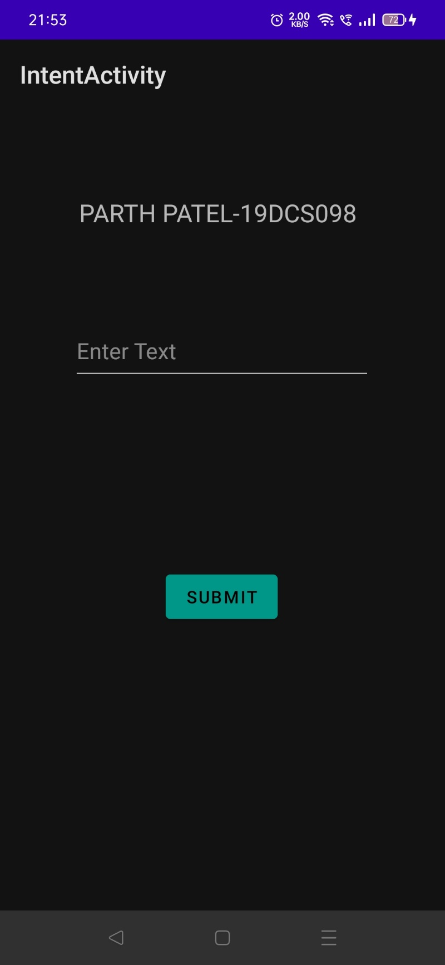

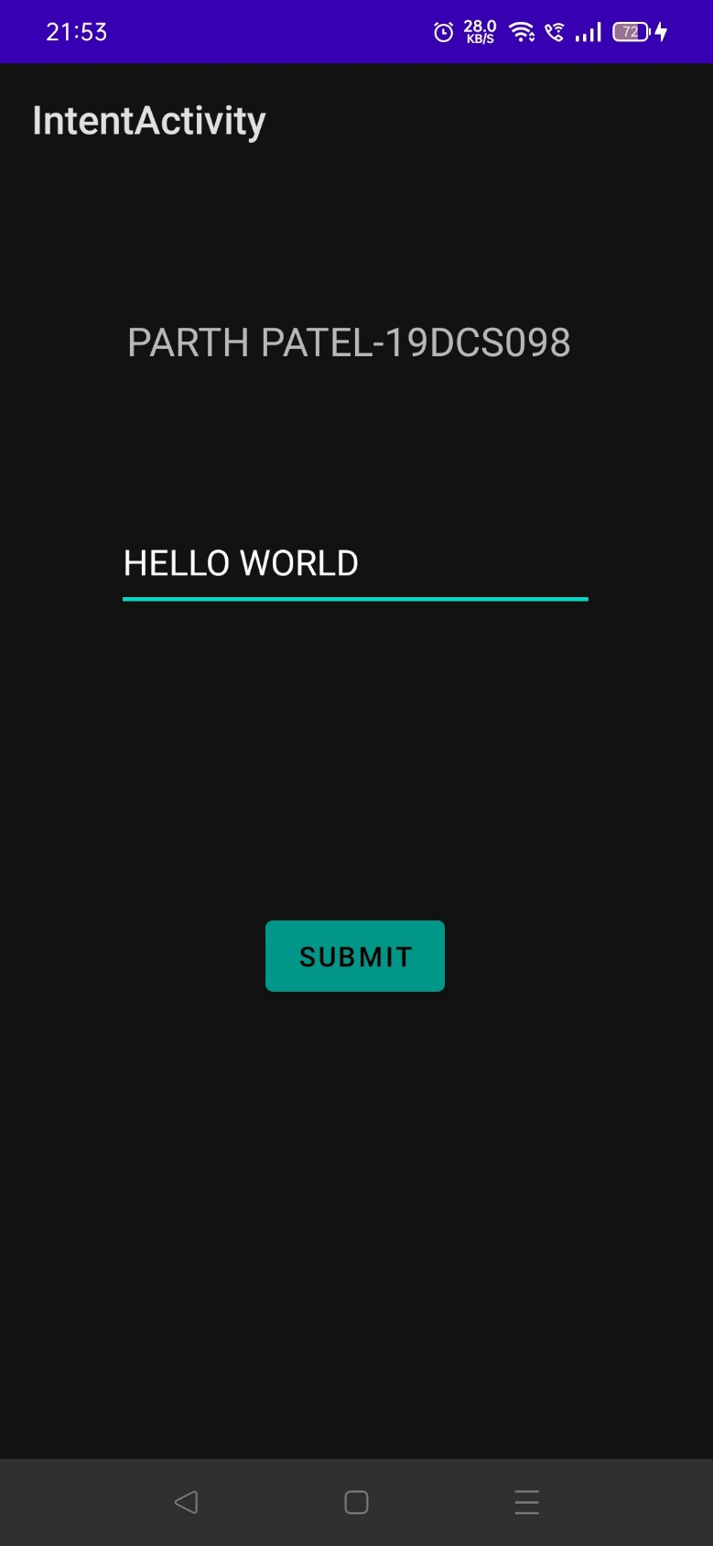

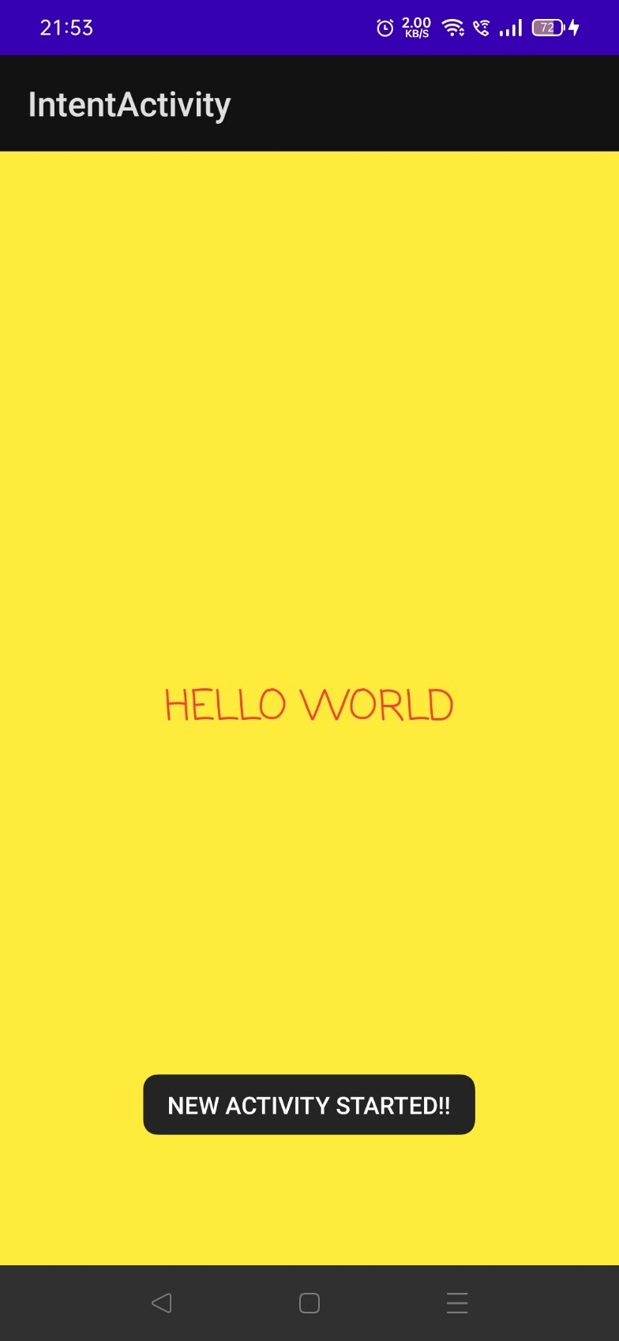

**TEXT ENTERED IN THE FIRST ACTIVITY IS TRANSFERRED TO SECOND ACTIVITY VIA INTENT WHERE THE TEXT IS DISPLAYED.**

